Basic Questions (30 questions)
※ The below explains Three Principles of Robots, described in ‘I, Robot’, one of the long novels by Issac Asimov.
1st Principle- Robots should not harm humans, nor should ignore humans facing danger.
2nd Principle – Robot must obey humans’ command. A case going against the 1st Principle is an exception.
3rd Principle – Robots should protect themselves. A case going against the 1st and the 2nd Principles is an exception.

1. Which of the following robots goes against Three Principles of Robots. ( 2 )
➀ Housekeeping robot ② Attacking military robot
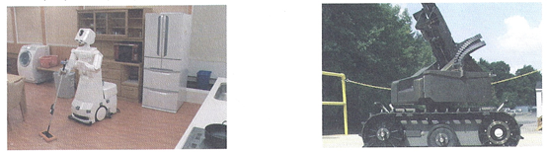

③ Industrial robot ④ Medical robot
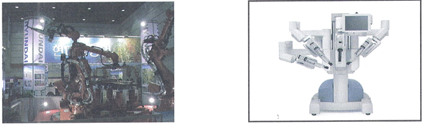

2. Which of the followings should be the most protected according to the 3rd Principle? ( 2 )
① Robot ② Human ③ Robot builder ④ Robot user

3. What is the origin of the word “Robot”? ( 1 )
① Robota ② Robocom ③ Humanoid ④ Transformer

4. What is called a robot similar to humans? ( 3 )
① Housekeeping robot ② Pet robot ③ Humanoid robot ④ Micro robot

5. Which of the followings could be considered a robot? ( 4 )
① Hammer ② Electric saw ③ Fluorescent light ④ Crane

6. Which description is not correct to explain a robot? ( 4 )
① Among Three Principles of Robot, humans should be the most respected.
② The term “Robot” was first used by ‘Issac Asimov’.
③ The term “Robot” was originated from ‘Robota’ which means ‘forced labor’.
④ Blinkers and electric pads can be considered robots as they are equipped with a sensor.

7. Most of residences have computers, mobile phones and cars. It is not too long for us to have one or more unit of robot per residence. Which is not a desirable example that describes living with a robot at home? ( 3 )
① The robot can entertain us.
② The robot can protect my family.
③ The intelligent robot can do all my homework instead of me.
④ The robot can help maintaining pleasant home environment.

8. The picture describes a mechanical element that can be used for robot motions. It has saw-teeth and is usually used by putting an axis. What kind of mechanical element is this? ( 1 )
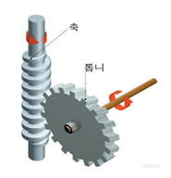
① Gear
② Belt
③ Chain
④ Pulley

9. Which body part corresponds to the motor in the robot? ( 3 )
① Eyes ② Ears ③ Arms and Legs ④ Skin

10. A robot falls into water while running fast. What do you need to do first after fishing it out from water? ( 4 )
① Wipe out moist.
② Keep operating the robot.
③ Throw it away as it is useless.
④ Turn off power and take out batteries quickly.

11. The below part is frequently used to manufacture or assemble robots. What is the correct purpose of the part? ( 1 )
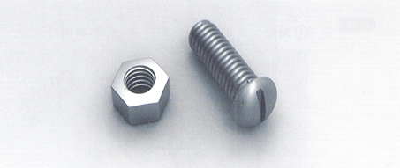
① To fix an object not to move
② To convey power
③ To generate energy
④ To turn an object

12. Magnets pull objects. Select the object not pulled by magnets. ( 2 )
① Iron powder ② Glass ③ Steel wire ④ Clip(iron)

13. Series connection of batteries may increase battery strength to brighten up light bulbs more. Select the series connection of batteries in the below examples. ( 2 )
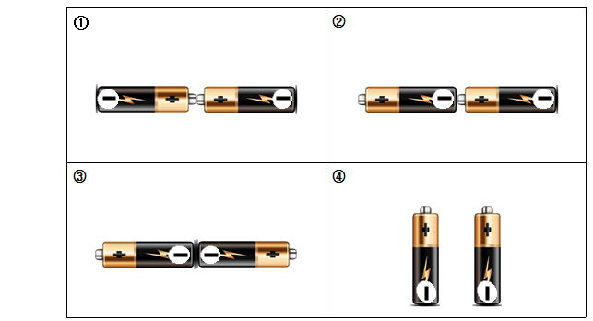

14. Which of the followings best describes the below phenomenon? ( 2 )
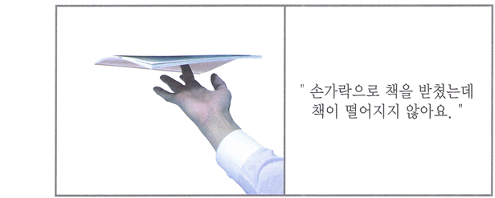
”I support a book with my fingers but the book doesn’t fall off”

- The book doesn’t fall off because the fingertips and the book are adhered by glue.
② The book doesn’t fall off because the fingers are placed at the very center of the book weight, making the book well-balanced.
③ The book doesn’t fall off because invisible flat glasses are placed right under the book.
④ The book doesn’t fall off because magnetic properties are generated on the fingers temporarily.

15. When you stretch a rubber band, a certain power makes it to return to its original state. What is this power? ( 3 )
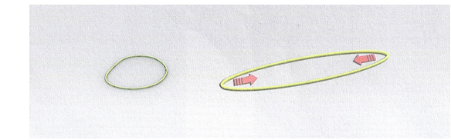
➀ Gravity ② Friction ③ Elasticity ④ Buoyancy

16. A chain is a metal wire that connects a gear to convey electric power to wheels. A sprocket is a device installed on the chain. Combining the chain and the sprocket is called a chain power unit. Which of the below product is moved by the chain power unit?( 3 )
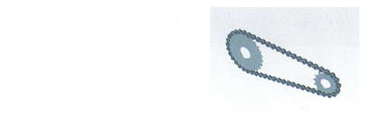
➀ Snowboard ② Inline Skate
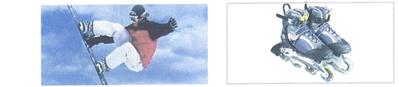

③ Bicycle ④ Ski
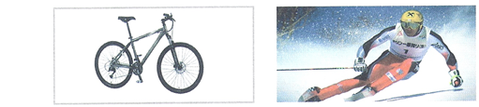

17. In which picture of the below does the object slide down the fastest? (Height of the triangle and weight of the object are the same for all pictures.) ( 1 )
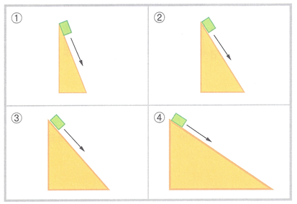

18. Children play seesaw in the picture. They are leveled in balance without being tilted into one side. To be leveled, distance and weight from the support point to both sides should be the same. Select the picture that best describes the seesaw principle. ( 4 )
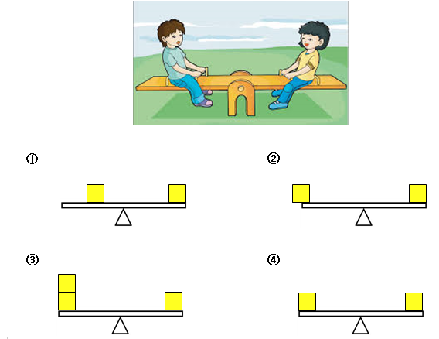

19. You want to move the robot to the destination on the right as shown in the below picture. How do you have to move the robot wheels? ( 1 )
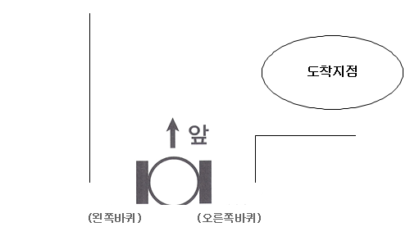
① (Left Wheel) Fast Turn, (Right Wheel) Slow Turn
② (Left Wheel) Slow Turn, (Right Wheel) Fast Turn
③ (Left Wheel) Fast Turn, (Right Wheel) Fast Turn
④ (Left Wheel) Slow Turn, (Right Wheel) Slow Turn
20. A line tracer is a robot moving following a drawn line. The sensor used in the line tracer follows a black line based on light reflection. What kind of sensor is used for the line tracer? ( 4 )
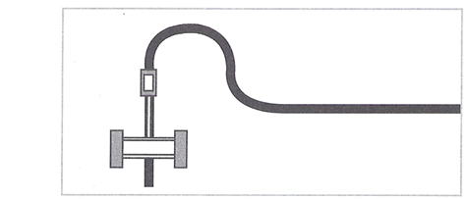
① Temperature sensor ② Ultrasound sensor ③ Ultraviolet-ray sensor ④ Infrared sensor

21. Which of the below matching between robot components and humans is not correct? ( 3 )
① Motor - Joint ② Sensor – Sensory system ③ Battery - Sensibility ④ Processor -Brain

22. What is called a robot that can move each finger, make smooth motions using several joints, and can walk like a human? ( 3 )
① Cyborg ② Biomimetic robot ③ Humanoid ④ Iron Man

23. The bellows are frequently used tools in our daily lives. Which does not use the principle of a lever? ( 4 )
① Scissors ② Can opener ③ Tweezers ④ Flagstaff

24. Which of the followings transfers electric signals to sound signals? ( 1 )
① Speaker ② Switch ③ Light bulb ④ Resistance

25. What is an instrument used to measure voltage, current and resistance? ( 4 )
① Nipper ② Iron ③ Long nose ④ Tester

26. Which descries the unit of resistance, capacitor, voltage and current correctly?( 2 )
 | Resistance | Capacitor | Voltage | Current
 | Ω(ohm) | A(amp) | V(volt) | F(farad)
 | Ω(ohm) | F(farad) | V(volt) | A(amp)
 | Ω(ohm) | F(farad) | A(amp) | V(volt)
 | A(amp) | F(farad) | V(volt) | Ω(ohm)

27. After building a line tracer, you place it on the black line diagonally to test the sensor as shown in the picture. To move the line tracer toward the arrow, how do you need to move (A) wheel and (B) wheel respectively? ( 2 )
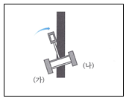
① (A):Forward, (B): Forward
② (A):Forward, (B): Same place
③ (A):Backward, (B): Same place
④ (A):Backward,(B): Forward

28. The sensor unit that identifies a black line mostly uses 2 sensors in the line tracer. The sensor distinguishes the black line and the white floor by shooting light and then sensing reflected light. The sensor unit consists of (A) that shoots light and (B) that senses amount of reflected light. What is the correct matching for A and B? ( 1 )
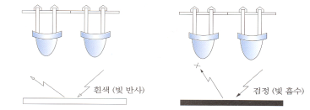
① A- Luminous part B- Receiving part ② A- Receiving part B- Luminous part
- A- Internal sensor B- External sensor ④ A- External sensor B- Internal sensor

29. It requires 6V of power to operate a line tracer. What is the correct method of using batteries? Voltage of one battery is 1.5V. ( 4 )
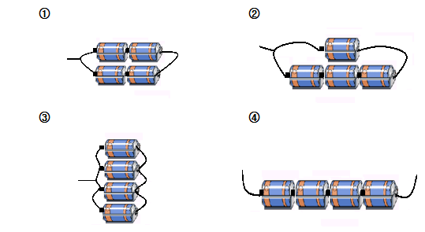

30. You want to build a robot that moves in a bright place (place with light) and that does not move in a dark place (place without light). The below picture is the flow chart of the robot motions. What should be in (A)? ( 1 )
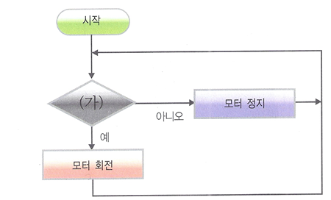
① Is there light? ② Is there any sound?
③ Is the robot strong? ④ Is the battery inserted?

Additional Questions (20 questions)

31. Which of the following does not describe your experience in Robot Exhibition? ( 3 )
① I learned different kinds of robots.
② I observed robot motions.
③ I built a robot myself or disassembled the presented robot for modification.
④ I was amazed by various technology used in robots.

32. The below describes how to use batteries. What is the correct method of using batteries? ( 3 )
① Throw away used batteries to trashcan.
② Batteries purchased 1~2 years ago but not used are almost like new batteries.
③ Batteries have ＋,－ polarity and they should be sued in correct polarity.
④ Batteries should be stored in a place with sunlight.

33. The below describes some effects generated in using a robot. What is incorrect? ( 1 )
① It is hard for a robot to do precision work.
② A robot can do repetitive works for a long time continuously.
③ A robot can do works instead of humans in a place where humans cannot easily do works.
④ A robot can make the same quality products and reduce defected products.

35. Which is not the correct definition of a robot? ( 4 )
① A robot has the same motor skills as humans.
② A robot is a widely used machine with comprehensive intelligence
③ A robot is a human-shaped machine
④ A robot has the same emotion as humans.

36. Humans recognize external objects through sensory system such as eyes, nose, ears, mouth and skin. Which of the robot components plays the same role as the human’s sensory system? ( 2 )
① Motor ② Sensor ③ Battery ④ Processor

37. A robot is exploring the surface of Mars as shown in the below picture.
What is not the correct reason to send a robot to planets in the universe for exploration? ( 4 )
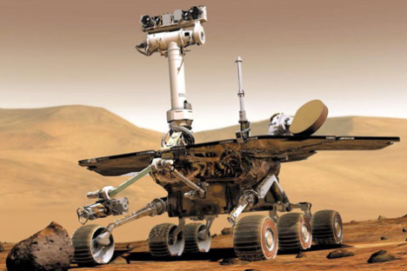
① Other planets have different environment than the earth.
② A robot can fulfill dangerous tasks that humans cannot.
③ A robot can overcome extremely serious environment totally different from the earth and make exploration.
④ We do not need to go to other planets that humans do not live.

38. What should you do to fix a right hand screw? ( 1 )
①Turn to right. ②Turn to left. ③Turn top to bottom. ④It is not fixed.

39. Which kid has the most excellent skill in robot building? ( 3 )
① Jinkyu: disassembles and reassembles a toy robot well.
② Suhyeon: plays well with an already-built robot.
③ Jinhee: can make a new robot and create a program to make it motion in various ways.
④ Byeongsun: can control movement of a robot through a remote control.

40. In the movie ‘Iron Man’, a robot suit (wearing robot) appears. Which explanation of the robot suit is incorrect? ( 4 )
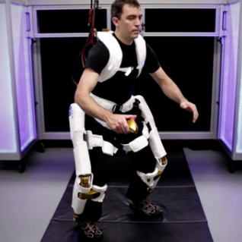
① It is a robot that humans can wear like clothes.
② It is the same shape as clothes but has robot functions.
③ It takes less power to load or lift up heavy objects while you wear a robot suit.
④ It is a robot clothes that make humans transparent.

41. Which best describes the role of a switch? ( 2 )
① It helps smooth flow of electricity.
② It connects and disconnects electric path to control electric flow.
③ It blocks electric flow.
④ It is not related to electric flow.

42. A lever has three points (force point, support point, application point). Which is the correct combination of three points in (A), (B), (C)? ( 1 )
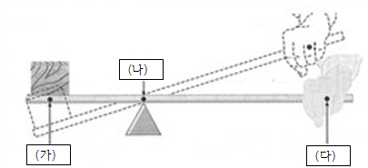

 | (A) | (B) | (C)
① | Application Point | Support Point | Force Point
② | Force Point | Support Point | Application Point
③ | Support Point | Application Point | Force Point
④ | Application Point | Force Point | Support Point

43. The picture is a gear unit that can be used in a robot. Which of the followings does not describe the picture incorrectly? ( 4 )
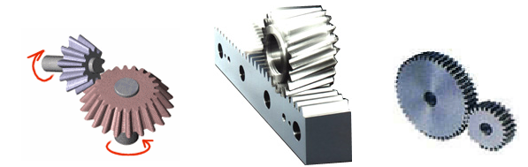
(A) (B) (C)
① (A) is used to deliver electric power to the orthogonal direction.
② In (A), speed of both axes is different when the ratio of connected gear (gear count) is different.
③ (B) can transform a circular motion to a linear motion.
④ In (C), direction of electric power can be changed to a right angle.

44. Which of the below explanations of a pulley is incorrect? ( 4 )
① A fixed pulley does not change application direction of force.
② A movable pulley does not change magnitude of force.
③ A movable pulley is used to scoop up water from a well.
④ A pulling distance is longer than an actual object-moving distance in a movable pulley.

45. Wheel and axle is an instrument to obtain force by turning the wheel and axle at the same time while the wheel is fixed onto the axle. Wheel and axle also uses the principle of a lever; it lessens the amount of force to be used by making the distance between force points longer than that between a support point and an application point. Which of the followings not use wheel and axle? ( 2 )
① Screwdriver ② Tweezers ③ Vehicle handle ④ Faucet

46. Which of the followings cannot be measured by a tester? ( 3 )
① Voltage ② Current ③ Temperature ④ Resistance

47. You place the changeover switch in the circuit tester to DCV 10 for measurement and indication of the dial is as shown in the below picture. What is the voltage value measured? ( 2 )
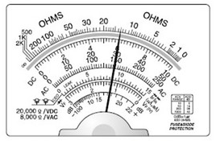
① 15V
② 6V
③ 30V
④ 150V

48. What is the name of robot parts corresponding to human brain? ( 4 )
① Voice board ② Infrared sensor ③ Motor ④ CPU

49. What is the word that the below explanation indicates? ( 3 )
•It is one of SI prefixes in International System of Units (SI). It means one billionth (10-9).
•○○ technology is a technology that makes and controls an extremely small sized element. This technology can be applied not only to electronic and IT fields but also to almost all kinds of industries including machine, chemical, and bio/energy, emerging as a revolutionary technology that can change human civilization.
•○○robot may appear. This robot may penetrate into blocked blood vessels and treat cancerous tumors by traveling around human blood vessels.
① Kilo ② Mega ③ Nano ④ Giga

50. Which of the followings only uses 0 and 1 for data in IC digital circuits? ( 1 )
① Binary ② Tetrad ③ Octal ④ Decimal

